Fundamentals of Data Structure And Algorithms

Github Link:
https://github.com/rudraaaajoshi/FDSA_BATCH_A/tree/main/Practical-3

Practical-3.1
Difficulty:
The main difficulty was understanding the different ways of sorting the marks using Bubble Sort, Selection Sort, and Insertion Sort. I was also confused about how elements move to their correct positions in each method.
Error:
Sometimes the marks were not arranged in the correct order because the comparison or swapping was not performed properly. I also faced difficulty while checking whether the final sorted array was completely correct.
Solution:
I used proper if conditions to compare the marks. For swapping, I used a temporary variable so that the values were not lost. In Insertion Sort, I used a key value and compared it with the previous elements before placing it in the correct position.
Outcome:
I successfully implemented all three sorting methods and obtained the marks in sorted order. I also understood that different sorting algorithms can use different approaches to arrange the same data.
Code Link:
https://github.com/rudraaaajoshi/FDSA_BATCH_A/blob/main/Practical-3/pr-3.1.cpp
Output:
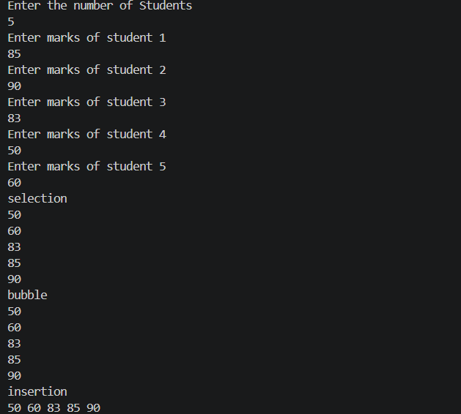
KEY QUESTION:
Problem-1
One of the three methods can detect early that the list is already sorted and stop without doing any more work. Which method is it, how would you add that detection, and why can the other two not do the same?
Answer:
Bubble Sort can be modified to stop early by using a swapped variable. If no swap occurs during a complete pass, the list is already sorted, so the algorithm stops. Selection Sort cannot stop early because it still needs to search for the minimum element in the remaining par

Practical-3.2
Difficulty:
The main difficulty was understanding where each value should be placed so that all 0s come first, followed by 1s and then 2s. Managing the different indexes was also slightly confusing.
Error:
I initially made mistakes while changing the elements in the same array. Sometimes the indexes were not updated correctly after a swap, which could result in some elements being skipped or placed incorrectly.
Solution:
I carefully used the indexes to identify the positions of 0, 1, and 2. Instead of creating another array, I used swapping to rearrange the elements directly in the original array. I also updated the indexes carefully after every operation.
Outcome:
I successfully rearranged the array so that all 0s appeared first, followed by 1s and 2s. I learned how an array can be modified directly without using extra storage.
Code Link:
https://github.com/rudraaaajoshi/FDSA_BATCH_A/blob/main/Practical-3/pr-3.2.cpp
Output:
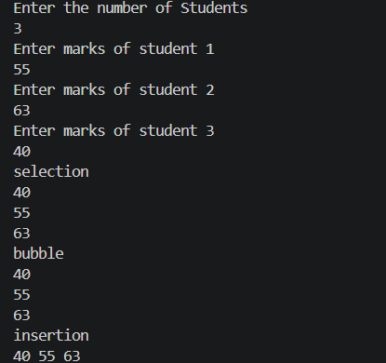
Key Question:
Problem-2
If your solution makes two passes through the list, can you identify which decision in your logic forces the second pass? Is there a way to restructure that decision to eliminate it?
Answer:
The second pass is caused by separating the counting and rearranging operations. We can eliminate it by rearranging elements during the same traversal using three pointers. This allows the problem to be solved in one pass with O(n) time and O(1) extra space.

